**CLASSIFICATION ASSIGNMENT**

Problem Statement or Requirement: A requirement from the Hospital, Management asked us to create a predictive model which will predict the Chronic Kidney Disease (CKD) based on the several parameters. The Client has provided the dataset of the same.

1.) Identify your problem statement. **Supervised Classification**

2.) Tell basic info about the dataset (Total number of rows, columns). **399 rows × 28 columns**

3.) Mention the pre-processing method if you’re doing any (like converting string to number – nominal data) **Using get_dummies converting string to number**

4.) Develop a good model with good evaluation metric. You can use any machine learning algorithm; you can create many models. Finally, you have to come up with final model. **Decision Tree**

5.) All the research values of each algorithm should be documented. (You can make tabulation or screenshot of the results).

6.) Mention your final model, justify why u have chosen the same. **Decision tree because it is a good model with 0.99 accuracy.**

**5. EVALUATION METRICS O/P:**

**SVC:**

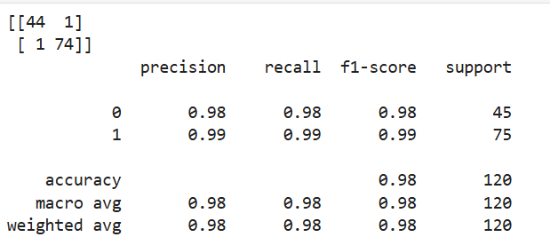

**Random Forest:**

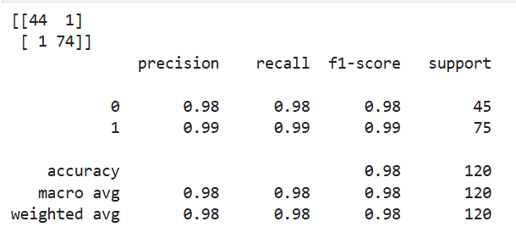

**Decision Tree:**

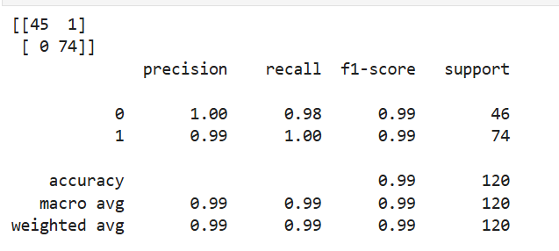

**Logistic Regression:**

